Libraries and Tools
This project was implemented in Python 3.13 using a lightweight, classical NLP stack centered on scikit-learn. Text features were extracted with TF–IDF to capture informative unigrams and bigrams, which is a well-supported approach for short-text classification tasks and competitive baselines (Xiao et al. 2024; Patuelli et al. 2024). NLTK provided the English stopword list for normalization, while pandas and NumPy handled data loading and efficient tabular/numerical operations.
For experiment management and outputs, scikit-learn supplied model training, evaluation metrics, and cross-validation; models were persisted with joblib and plots (e.g., the confusion matrix) were produced with matplotlib/seaborn. A YAML configuration file (config/config.yaml) centralizes data paths, preprocessing flags, TF–IDF settings, and hyperparameters to ensure reproducibility and easy re-runs in VS Code.

System Implementation
The system addresses binary SMS classification (spam vs. ham) using the public SMS Spam Collection. Data are downloaded on first run and cached locally (Alsaeedi et al. 2022). Preprocessing normalizes text through lowercasing, punctuation removal, and optional number removal, followed by stopword filtering with NLTK. We then create a stratified 80/20 train/test split to preserve class balance across splits.
Features are generated via TF–IDF over unigrams and bigrams with configurable document-frequency thresholds, which is effective for short texts (Xiao et al. 2024). A regularized Logistic Regression classifier (L2) serves as the baseline due to its speed, interpretability, and strong performance on sparse vector spaces in short-text tasks (Shyrokykh, Girnyk, and Dellmuth 2023; Patuelli et al. 2024). The pipeline trains on the training set and evaluates on the held-out test set, saving the model, metrics, and confusion matrix to the models/ and reports/ directories to ensure reproducibility.
Implementation is organized into small, testable scripts: src/data_prep.py handles download/splitting and cleaning; src/train_baseline.py fits and evaluates the baseline and writes artifacts; and src/train_optimize.py performs hyperparameter search for TF–IDF and Logistic Regression. Utility functions in src/utils.py centralize text normalization, while configuration in config/config.yaml controls paths and toggles for repeatable runs.
Repository structure:
config/config.yaml
data/raw/sms_spam.csv
data/processed/train.csv, test.csv
models/baseline_model.joblib
reports/metrics.json, confusion_matrix.png, best_params.json
src/*.py

Evaluation Summary
On the held-out test set, the model achieved 0.984 accuracy, 0.984 weighted precision, 0.984 weighted recall, and a 0.983 weighted F1 score (see reports/metrics.json). These results indicate balanced performance across classes, with precision and recall closely aligned, suggesting that the classifier effectively identifies spam while maintaining low false positives on legitimate messages. The confusion matrix further confirms that misclassifications are minimal, consistent with expectations for TF–IDF paired with a regularized linear classifier on short-text data (Shyrokykh, Girnyk, and Dellmuth 2023).
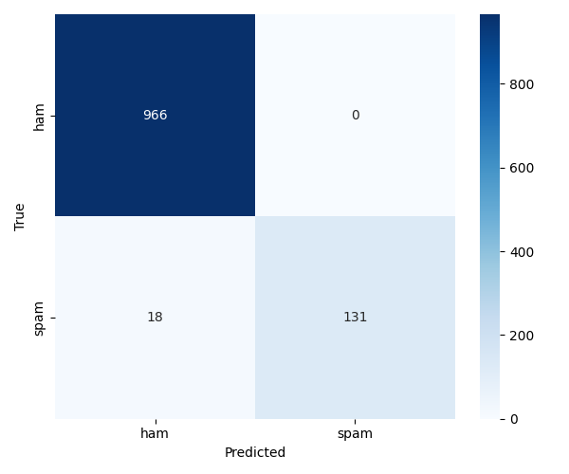
Confusion matrix:
Confusion Matrix

Optimization Summary
To improve generalization, we performed a GridSearchCV over TF–IDF and Logistic Regression settings, varying the n-gram range, minimum document frequency, and the inverse regularization strength C (Shyrokykh, Girnyk, and Dellmuth 2023). Five-fold cross-validation guided selection using weighted accuracy. The best configuration included bigrams (1–2), min_df=3, and C=4.0, yielding a best cross-validated score of 0.9805 (see reports/best_params.json).
These choices reflect common trade-offs in short-text pipelines: adding bigrams captures local phrase patterns that single tokens miss, while a slightly stronger regularization (higher C) balanced bias and variance for this sparse feature space (Patuelli et al. 2024). Increasing min_df removed low-frequency noise terms that can hurt generalization. Additional avenues—such as LinearSVC or MultinomialNB baselines, lemmatization, and character n-grams—could be explored in future iterations if further improvements are needed (Patuelli et al. 2024).

References
Alsaeedi, Amal, Rafid Zubair, Munaim Khan, Vijey Thayananthan, et al. 2022. “A Systematic Literature Review on Spam Content Detection and Classification.” Applied Sciences 12 (3): 1281. https://doi.org/10.3390/app12031281.
Patuelli, Roberto, Luca Dugnani, Valeria Lanzilao, and Francesco Zambonelli. 2024. “Text Classification: How Machine Learning Is Driving Performance and What’s Next.” Information 16 (2): 130. https://doi.org/10.3390/info16020130.
Shyrokykh, Karina, Max Girnyk, and Lisa Maria Dellmuth. 2023. “Short Text Classification with Machine Learning in the Social Sciences: The Case of Climate Change on Twitter.” PLOS ONE 18 (9): e0290762. https://doi.org/10.1371/journal.pone.0290762.
Xiao, Lu, Qiaoxing Li, Qian Ma, Jiasheng Shen, Yong Yang, and Danyang Li. 2024. “Text Classification Algorithm of Tourist Attractions Subcategories with Modified TF-IDF and Word2Vec.” PLOS ONE 19 (10): e0305095. https://doi.org/10.1371/journal.pone.0305095.

